I. Reflective Writing
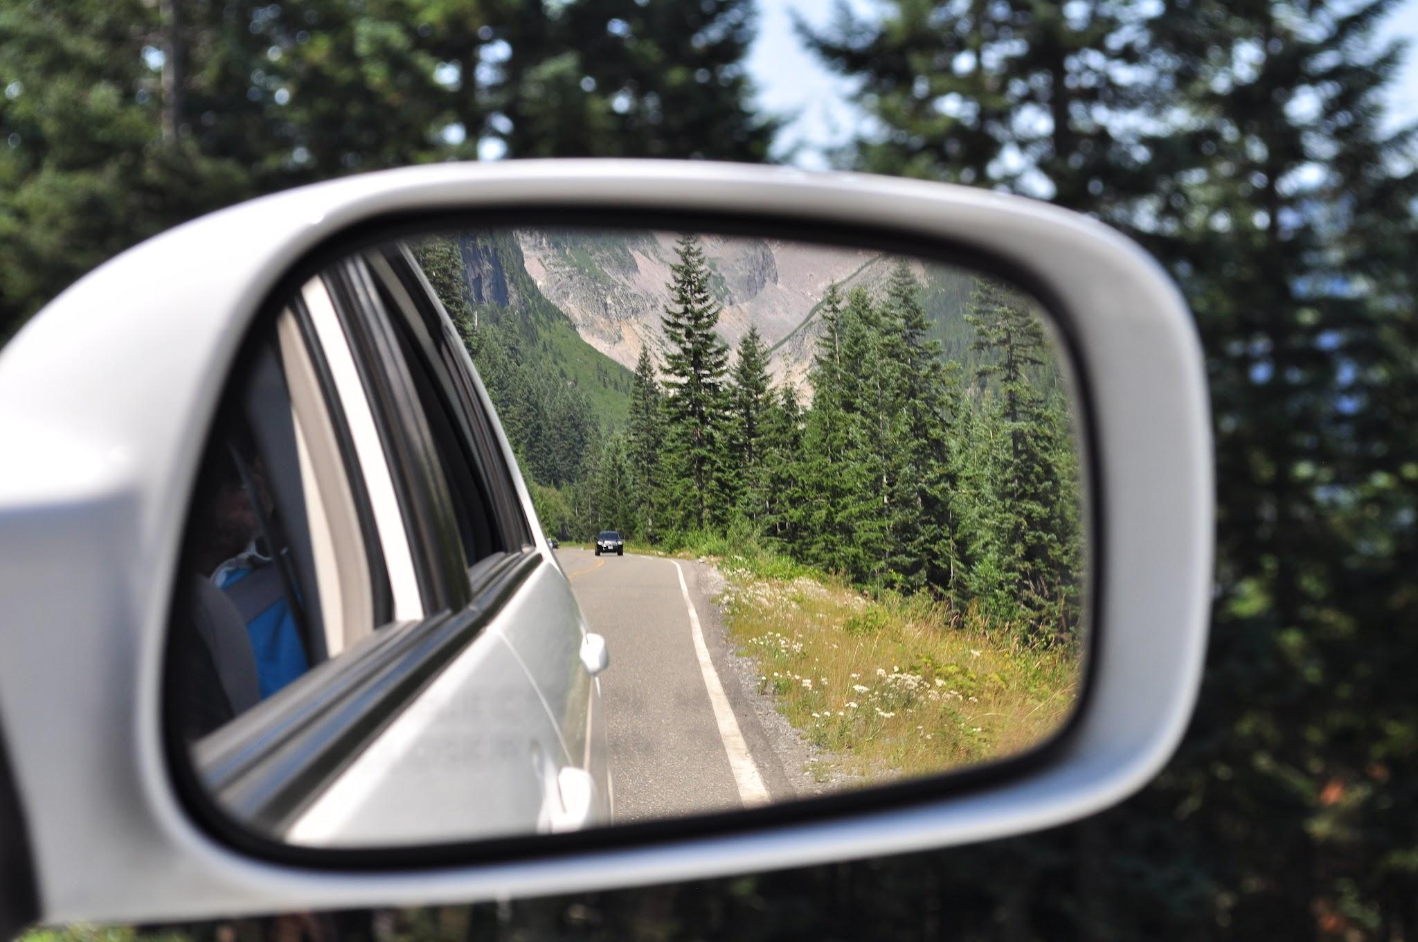
I. Life Through the Rearview Mirror
Soren Kierkegaard once wrote that life, although it “must be lived forward…can only be understood backwards.” We often fail to understand our lives as we are living them. Only by stepping back – often years later – can we grasp why something happened or how we were transformed by it.

How has this been true for you in your own personal life and experiences?
Give concrete examples to illustrate your thinking.

_________________________________________________________________________
_________________________________________________________________________
_________________________________________________________________________
_________________________________________________________________________
_________________________________________________________________________
_________________________________________________________________________
_________________________________________________________________________
_________________________________________________________________________
_________________________________________________________________________
_________________________________________________________________________
_________________________________________________________________________
_________________________________________________________________________
_________________________________________________________________________
_________________________________________________________________________
_________________________________________________________________________
_________________________________________________________________________
_________________________________________________________________________
_________________________________________________________________________
_________________________________________________________________________
_________________________________________________________________________

How is this idea also true of studying history? Illustrate with concrete details, either past (something we only understand now, many years later) or present (something happening now that we cannot fully comprehend until we have some distance).

_________________________________________________________________________
_________________________________________________________________________
_________________________________________________________________________
_________________________________________________________________________
_________________________________________________________________________
_________________________________________________________________________
_________________________________________________________________________
_________________________________________________________________________
_________________________________________________________________________
_________________________________________________________________________
_________________________________________________________________________
_________________________________________________________________________
_________________________________________________________________________

Is it harder to be certain about the recent past or the distant past? Briefly justify your position.

_________________________________________________________________________
_________________________________________________________________________
_________________________________________________________________________
_________________________________________________________________________
_________________________________________________________________________
_________________________________________________________________________
_________________________________________________________________________
_________________________________________________________________________

II. Intro to History
II. “Intro to History”
Watch the video by Bob Bain from the OER Project and answer the following questions:

- How does Bob Bain answer the question, "What do historians do?" (00:00 - 02:44)
___________________________________________________________________
___________________________________________________________________
___________________________________________________________________
___________________________________________________________________

- Why does Bain say that doing history is a lot like "understanding a mystery”? (02:45 - 02:59)
___________________________________________________________________
___________________________________________________________________
___________________________________________________________________
___________________________________________________________________

- According to Bain, how is science different from history? (03:00 - 03:15)
___________________________________________________________________
___________________________________________________________________
___________________________________________________________________
___________________________________________________________________

- Do all historians ask the same questions? (05:00 - 07:38)
___________________________________________________________________
___________________________________________________________________
___________________________________________________________________
___________________________________________________________________

III. Thinking Like a Historian
III. “Thinking Like a Historian”
From Khan Academy

What does it mean to "think like a historian"? It doesn’t mean you have to wear a tweed jacket with elbow patches or grow a long, white beard. Instead, thinking like a historian is about being a combination of three different roles: a Storyteller, a Scientist, and a Lawyer.

The Storyteller: Cause, Effect, and Agency
In a good story, nothing "just happens." If the wind blows and the earth turns, that’s a boring story because there is no human choice involved. History is the same way.

We often fall into the trap of treating history like a laundry list of events, saying things like, "And then World War II happened," or "And then the United States was born." That is the passive voice. It ignores the fact that, short of a natural disaster, everything in history happens because people made choices.

When you think like a historian, you think like a novelist:
- What is this person’s motive?
- What are the influences leading them to make a certain choice?
- What are the consequences of that action?

History isn’t a list of inevitable events; it is a web of human actions and their effects.

 | If we focus only on "human agency" (choices), are we ignoring larger forces like geography, climate, or economics?

The Scientist: Evidence and Revised Theories
We often think of history as "done"—a series of settled facts we just need to memorize. But in reality, our knowledge of the past is limited. Historians, like scientists, work with theories.

For example, a historian might have a theory that Jazz became popular in the 1920s because people were reacting to the horrors of World War I. To prove that theory, they must consult evidence: they read letters, diaries, and documents.

However, our understanding of the past is always subject to change. New information comes to light all the time—someone cleans out their grandmother’s attic and finds a new trunk of letters—and as the weight of evidence shifts, our "theories" about the past must change too. History is an ongoing process of research, not a finished book.

If history is based on "theories" that can change, can we ever claim to have "historical truth"?

The Lawyer: The Power of Interpretation
Finally, historians are like lawyers because they are always making an argument. A historian says, "Believe my theory. Believe my evidence."

The most powerful part of this analogy is that two different people can look at the exact same piece of evidence and reach different conclusions. Imagine a sock found at a crime scene:
- The Prosecution argues the sock proves the defendant is guilty because it is his size.
- The Defense argues the sock proves he is innocent because the defendant only ever wears sandals and doesn't own socks.

This is why we have so many different interpretations of the same historical event. The task of the historian is to gather evidence and present an argument that best convinces the public of their specific interpretation.

The speaker says historians try to "convince" the public. Does this mean history is more about persuasion than it is about facts?

Why It Matters
Thinking like a historian isn't just for academics. It’s a life skill. We tell stories, search for evidence, and make arguments every day—whether we are talking about our favorite bands, our favorite foods, or our political views. History isn't a "foreign country"; it is simply the remnants of the past, waiting for us to interpret them.

Choose one of the three questions to respond to in a brief reflective paragraph.

_________________________________________________________________________________

_________________________________________________________________________________

_________________________________________________________________________________

_________________________________________________________________________________

_________________________________________________________________________________

_________________________________________________________________________________

_________________________________________________________________________________

_________________________________________________________________________________

_________________________________________________________________________________

IV. History as a Debate
IV. History as a Debate
Watch the TEDx Talk, History as an Unnatural Act, and answer the questions below.
- Walker defines history not as a set of facts, but as a debate about the past (4:09). How does this definition fundamentally change the goal of studying history compared to treating it as simply learning a series of dates and events?
_________________________________________________________________________________
_________________________________________________________________________________
_________________________________________________________________________________
_________________________________________________________________________________
- The speaker implies that mere memorization is insufficient for true understanding. How does treating history as a “debate” instead of a set of agreed-upon facts help overcome the limitations of passive memorization?
_________________________________________________________________________________
_________________________________________________________________________________
_________________________________________________________________________________
_________________________________________________________________________________
- When analyzing the example of Abraham Lincoln, Walker uses specific documents and contexts to evaluate him (9:26-11:52). What criteria does Walker suggest for selecting which historical documents or events are necessary to understand a person's true impact?
_________________________________________________________________________________
_________________________________________________________________________________
_________________________________________________________________________________
_________________________________________________________________________________
- Walker argues that understanding history is an “unnatural act” because we must look beyond our own immediate thoughts and experiences (3:40-3:54). How does our current perspective and context act as a filter that hinders our ability to truly empathize with historical figures?
_________________________________________________________________________________
_________________________________________________________________________________
_________________________________________________________________________________
_________________________________________________________________________________

Inspired by the video, create visual notes that represent what history is, and what it is not.

Formative: History Discussion

Group 1

Discuss the main ideas, arguments, and questions that emerged from Activity 1: Life Through the Rearview Mirror.

Knowledge Questions to Consider
- Is certainty about the past more difficult to attain than certainty about the present or the future?
- Are we more prone to particular cognitive biases (such as hindsight bias) in some disciplines and areas of knowledge rather than others?

Quotes about History
- “The past is a foreign country; they do things differently there.”
  - L.P. Hartley

- “After the event, even a fool is wise.”
  - Homer

- “The best prophet of the future is the past.”
  - Lord Byron

- “Nowhere is it ordained that history moves in a straight line.”
  - Barack Obama

- “History is merely a list of surprises. It can only prepare us to be surprised yet again.”
  - Kurt Vonnegut

Closing Question

How does the “rearview mirror” concept apply to how we understand major news events today versus five years from now?

Outer Circle Tracker

Strong Arguments
Student | What they argued | Why was it convincing?

Excellent Builds

Student A argued | Student B built on this by saying

I Would Have Said…
Topic Addressed | What you wish you could have added

Group 2

Discuss the main ideas, arguments, and questions that emerged from Activity 2: Intro to History and Activity 3: Thinking Like a Historian
Knowledge Questions to Consider
- How might the existence of different historical perspectives be beneficial to historical knowledge?
- How do empathy and imagination help us to understand other perspectives?

Quotes about History
- “God cannot alter the past, though historians can.”
  - Samuel Butler

- “The history of the world is the biography of the great man…. ”
  - Thomas Carlyle

- “History is a pack of lies about events that never happened told by people who weren't there.”
  - George Santayana

- “History cannot give us a program for the future, but it can give us a fuller understanding of ourselves, and of our common humanity, so that we can better face the future.”
  - Robert Penn Warren

- “Every new generation must rewrite history in its own way; every new historian, not content with giving new answers to old questions, must revise the questions themselves.”
  - R.G. Collingwood
Closing Question
If a historian 100 years from now writes the story of the 2020s, what great people or generational forces will they focus on?

Outer Circle Tracker

Strong Arguments
Student | What they argued | Why was it convincing?

Excellent Builds

Student A argued | Student B built on this by saying

I Would Have Said…
Topic Addressed | What you wish you could have added

Group 3

Discuss the main ideas, arguments, and questions that emerged from Activity 2: Intro to History and Activity 3: Thinking Like a Historian

Knowledge Questions to Consider
- How are facts or proof decided upon in history?
- If it is difficult to establish proof in history, does that mean that all versions are equally acceptable?

Quotes about History
- “The historian without his facts is rootless and futile; the facts without their historian are dead and meaningless.”
  - E.H. Carr

- “History is a set of lies agreed upon.”
  - Napoleon Bonaparte

- “The past changes a little every time we retell it.”
  - Hilary Mantel

- “To study history means submitting to chaos and nevertheless retaining faith in order and meaning.”
  - Hermann Hesse

- “Very few things happen at the right time, and the rest do not happen at all. The conscientious historian will correct these defects.”
  - Herodotus

Closing Question
With the rise of deepfakes and AI, will it be harder or easier for future historians to act as scientists establishing facts?

Outer Circle Tracker

Strong Arguments
Student | What they argued | Why was it convincing?

Excellent Builds

Student A argued | Student B built on this by saying

I Would Have Said…
Topic Addressed | What you wish you could have added

Group 4

Discuss the main ideas, arguments, and questions that emerged from Activity 2: Intro to History and Activity 4: The Unnatural Act
Knowledge Questions to Drive the Discussion:
- Can the historian be free of bias in the selection and interpretation of material?
- Given the presence of competing perspectives, on what criteria can a historian evaluate the reliability of their sources?
Quotes about History
- “Until the lions have their own historians, the history of the hunt will always glorify the hunter.”
  - Chinua Achebe
- “Who controls the past controls the future. Who controls the present controls the past.”
  - George Orwell
- “History is written by the victors.”
  - Winston Churchill
- “All historical writing, even the most honest, is unconsciously subjective, since every age is bound, in spite of itself, to make the dead perform whatever tricks it finds necessary for its own peace of mind.”
  - Carl Lotus Becker
- “The past is a foreign country; they do things differently there.”
  - L.P. Hartley

Closing Question
In his TED Talk, Walker calls history an “unnatural act” because it requires us to step outside our own context. In today’s world of instant information and cancel culture, is it becoming harder or easier for us to truly empathize with the “unnatural” perspectives of the past?"

Outer Circle Tracker

Strong Arguments
Student | What they argued | Why was it convincing?

Excellent Builds

Student A argued | Student B built on this by saying

I Would Have Said…
Topic Addressed | What you wish you could have added

Formative: History Project
School History Project (TOK)

What can we know about a past community from a single source — and what will we inevitably get wrong?

Part 1: First Impressions
- What is your first impression of this school year?

- What feels familiar? What feels foreign or surprising?

Part 2: Investigating the Evidence

- What do you see?
  - List specific, concrete observations from the yearbook. Avoid interpretation here—just describe what you see.

- What patterns emerge?
  - What does this school seem to value most?
  - What kinds of students or achievements are emphasized?
  - What overall image of the school is being presented?

- What is missing?
  - Who or what seems underrepresented or invisible?
  - What parts of school life are likely not captured in this yearbook?
  - Why might these absences matter for understanding the past?

Part 3: Building a Historical Claim

- Complete the claim:
  - This yearbook suggests that in ________, this school was a place where…

    - Evidence (at least 3 pieces):

- Uncertainty:
  - What might you be wrong about? Why?

Part 4: Challenging Your Interpretation

- Now, construct a competing interpretation.
  - An alternative interpretation is that this school was actually a place where…

    - Reinterpreting the Evidence
(Use at least 2 of the same pieces of evidence, but explain them differently):

Part 5: Discussion & Debate

- Listen to another group share their competing interpretations
  - Which interpretation is more convincing? Why?

  - Did the difference come from the evidence or the interpretation?

  - Is it possible for both interpretations to be valid? Explain.

Part 6: The “Unnatural Act” of History

We often judge the past using today’s values.
- Identify something in the yearbook that feels strange, outdated, or problematic today

- Try to explain it from the perspective of someone at the time
  - What values or norms shaped this?
  - What context might you be missing?

Part 7: Final Reflection

- Corroboration
  - A big part of a historian’s work is corroboration — validating observations and inferences from one source with similar evidence in other reliable sources. What types of sources would a real historian use to corroborate the evidence you identified in Part 3 and 4?

Observations that need additional context or corroboration | Primary Source that would help fill in the gaps

- Awareness of Biases (Respond to some of these questions on the back)
  - How does your membership in the school community help you interpret the evidence of the past you found in the yearbook?
  - How does your membership in the school community make your interpretations less reliable?
  - Why is the yearbook itself a questionable primary source for gathering objective information about the school year?
  - Does our temporal distance from the events in the yearbook improve or limit our understanding of this moment in the past?

___________________________________________________________________________________________________
___________________________________________________________________________________________________
___________________________________________________________________________________________________
___________________________________________________________________________________________________
___________________________________________________________________________________________________
___________________________________________________________________________________________________
___________________________________________________________________________________________________
___________________________________________________________________________________________________
___________________________________________________________________________________________________
___________________________________________________________________________________________________
___________________________________________________________________________________________________
___________________________________________________________________________________________________
___________________________________________________________________________________________________
___________________________________________________________________________________________________
___________________________________________________________________________________________________
___________________________________________________________________________________________________
___________________________________________________________________________________________________
___________________________________________________________________________________________________
___________________________________________________________________________________________________
___________________________________________________________________________________________________
___________________________________________________________________________________________________
___________________________________________________________________________________________________
___________________________________________________________________________________________________
___________________________________________________________________________________________________
___________________________________________________________________________________________________
___________________________________________________________________________________________________
___________________________________________________________________________________________________

Summative: History Essay

The Haitian Revolution: Enlightenment or Bloodbath?

Early European historians often interpreted the evidence of the revolution through the lens of chaos and barbarism. They focused on the destruction of property and the violence of the uprising. Modern historians interpret the same evidence as the ultimate realization of the Enlightenment. They argue that the Haitian Revolution was more "revolutionary" than the French Revolution because it applied universal rights to all humans, regardless of race.

Source 1: Letter from a French Estate Overseer (October 1791)
“The night has lost its peace and is now filled only with the rhythmic, terrifying beat of drums echoing from the mountains—a sound that seems to summon the very earth to rise against us. Looking out from the balcony of the manor, the horizon is no longer the dark of the Caribbean sea, but a jagged line of crimson fire. The 'Black Spartacus' and his legions do not merely fight; they descend like a biblical plague.
They have turned the tools of industry into instruments of the macabre. I saw with my own eyes a troop of them carrying a standard that was not a flag, but a pike topped with the remains of a child of the colonies. They move with a ferocity that defies human reason, as if possessed by the very spirits they invoke in their forest ceremonies. There is no 'liberty' in their eyes—only a bottomless thirst for vengeance and the total erasure of the civilization we have spent two centuries carving out of this wilderness. We are no longer in a province of France; we are in the mouth of a very hell of horrors.”

Source 2: The Haitian Declaration of Independence (1804)
“It is not enough to have expelled from your country the barbarians who have bloodied it for two centuries; it is not enough to have put a brake to these ever-reviving factions which take turns to play with the liberty that France dangled before you... We must, with one last act of national authority, forever assure the empire of liberty in the country of our birth; we must take any hope of re-enslaving us away from the inhuman government that for so long kept us in the most humiliating torpor. In the end we must live independent or die.”
— Jean-Jacques Dessalines, Commander-in-Chief to the People of Haiti

Source 3: Secondary Source, “The Landscape of Destruction”
“By the time the revolution ended in 1804, Saint-Domingue—once the "Pearl of the Antilles" and the wealthiest colony in the world—was a smoking ruin. To ensure the French could not return to a functional economy, the revolutionary armies utilized a "scorched earth" policy. Over 1,000 plantations (sugar, coffee, and indigo) were systematically burned to the ground. The sophisticated irrigation systems and sugar mills, which represented millions of francs in French investment, were demolished.”

In the production of historical knowledge, is the interpretation of evidence more significant than the evidence itself?
Make a claim  Take a clear stance in response to the question | ____________________________________________________________________  ____________________________________________________________________  ____________________________________________________________________  ____________________________________________________________________  ____________________________________________________________________
Provide specific examples  Cite details from the case study provided that support your point | ____________________________________________________________________  ____________________________________________________________________  ____________________________________________________________________  ____________________________________________________________________  ____________________________________________________________________  ____________________________________________________________________  ____________________________________________________________________  ____________________________________________________________________  ____________________________________________________________________  ____________________________________________________________________  ____________________________________________________________________  ____________________________________________________________________  ____________________________________________________________________  ____________________________________________________________________  ____________________________________________________________________  ____________________________________________________________________  ____________________________________________________________________  ____________________________________________________________________  ____________________________________________________________________  ____________________________________________________________________  ____________________________________________________________________
Identify a limitation of your claim  Identify weaknesses in your claim, or other perspectives worth considering | ____________________________________________________________________  ____________________________________________________________________  ____________________________________________________________________  ____________________________________________________________________  ____________________________________________________________________  ____________________________________________________________________  ____________________________________________________________________  ____________________________________________________________________  ____________________________________________________________________  ____________________________________________________________________  ____________________________________________________________________
Explain how your claim and the limitation might be reconciled  How do the methods of the historian help resolve the tension between subjective interpretation and objective evidence? | ____________________________________________________________________  ____________________________________________________________________  ____________________________________________________________________  ____________________________________________________________________  ____________________________________________________________________  ____________________________________________________________________  ____________________________________________________________________  ____________________________________________________________________
What are the implications of your argument?  What does all of this mean for our collective memory or national identities or our ability to learn from the past? | ____________________________________________________________________  ____________________________________________________________________  ____________________________________________________________________  ____________________________________________________________________  ____________________________________________________________________  ____________________________________________________________________  ____________________________________________________________________  ____________________________________________________________________

